# Medium- and Heavy-Duty Vehicles (MHDV) GHG Emissions

[CSE Research Notes on Google Drive](https://docs.google.com/document/d/1QkU59g9KftWgeFvxq4vEP4iIVacogrZ-0wK56HplS5Y/edit?usp=sharing)

## Literature Review

* International Council on Clean Transportation (ICCT). April 2023. White Paper. <https://theicct.org/wp-content/uploads/2023/04/hdv-phase3-ghg-standards-benefits-apr23.pdf>
  + MHDVs account for 1/3 of CO2 emissions from on-road vehicles
    - Class 4-8 vehicles currently represent only 5% of on-road vehicle stock in the US but accounted for 32% of on-road CO2 emissions in 2020
      * EPA 2022; EPA 2022a
      * Medium-duty vehicles have gross vehicle weights ratings between 14,000 lbs and 16,000 lbs for Class 4, between 16,001 lbs and 19,500 lbs for Class 5, and between 19,501 lbs and 26,000 lbs for Class 6. Heavy-duty vehicles have gross vehicle weight ratings between 26,001 lbs and 33,000 lbs for Class 7, and above 33,000 lbs for Class 8.
  + Major MHDV manufacturers including Daimler, Ford, Navistar, Volvo have committed to increasing ZEV sales
  + Major companies have committed to electrifying their fleet (Amazon, DHL, FedEx, Ingka Group, Walmart)
  + Current baseline emissions
    - 1503 Million tonnes = 2019 LDV = HDV Tailpipe CO2 emissions (EPA)
  + Fully aligning the US MHDV sector with climate goals would require a 55% ZEV sales share in 2030, including a 40% ZEV sales share **for long-haul tractors**
    - There is little incentive to decarbonize long-haul trucks, yet long-haul trucks currently account for 60% of HDV CO2 emissions in the US
  + CA has adopted Innovative Clean Transit (ICT) rule that requires 100% zero-emission transit bus purchases in 2029 and proposed the Advanced Clean Fleets (ACF) rule, which includes various ZEV adoption requirements alongside a 100% zero-emission sales requirement in 2040 (CARB, 2022); worth checking out further
    - California Air Resources Board. (n.d.). Innovative Clean Transit 2018. Retrieved June 26, 2020, from https://ww2.arb.ca.gov/rulemaking/2018/innovative-clean-transit-2018
    - California Air Resources Board. (2022). Proposed Advanced Clean Fleets Regulation Staff Report: Initial Statement of Reasons. <https://ww2.arb.ca.gov/sites/default/files/barcu/regact/2022/acf22/isor2.pdf>
  + Classifications:
    - 1:
      * Rigid trucks (refuse trucks?)
      * Tractor truck, short-haul
      * Buses
      * Tractor-truck, long-haul
    - 2:
      * Class 4-8
        + Box trucks
        + Vans
        + Buses
      * Class 7-8
        + Work trucks
        + Day cab tractors
      * Class 8
        + Sleeper cab tractors
  + Drayage registry - <https://ww2.arb.ca.gov/drayage-truck-registration-guidance>
  + stock turnover modeled in ICCT’s Roadmap model – find data if possible?
  + *The U.S. EPA’s motor vehicle emissions simulator (MOVES) is an emissions model that estimates emissions of criteria air pollutant and greenhouse gases for mobile sources, including MHDVs, classified by source types (United States Environmental Protection Agency, 2022). Details on MHDV source types are presented in the Appendix.
    - look into difference between this model and EMFAC
      * MOVES dataset sounds similar to EMFAC, is it more up-to-date
      * check EMFAC for GHG emissions by class, emissions over a year
    - United States Environmental Protection Agency (U.S. EPA). (2022). MOVES3: Latest Version of Motor Vehicle Emission Simulator. <https://www.epa.gov/moves/latest-version-motor-vehicle-emission-simulator-moves>
    - U.S. EPA. (2022a). Inventory of U.S. Greenhouse Gas Emissions and Sinks: 1990-2020 (Reports and Assessments No. 430-R-22–003). U.S. Environmental Protection Agency. <https://www.epa.gov/ghgemissions/inventory-us-greenhouse-gas-emissions-and-sinks-1990-2020>
  + **pretty strong section in ‘climate and health social benefits of the policy scenarios’ that is worth checking out
  + A table with numbers and a number of numbers

    Description automatically generated with medium confidence
  + A screenshot of a computer

    Description automatically generated
* Drayage Truck Registration Guidance – CARB: <https://ww2.arb.ca.gov/drayage-truck-registration-guidance>
  + Login: <https://ssl.arb.ca.gov/trucrs_reporting/login.php>
  + No lead, database only for data entry, not review
* Drayage Director: <https://www.drayage.com/directory/results.cfm?city=SBD>
  + A screenshot of a computer

    Description automatically generated
  + A map of a city

    Description automatically generated
  + issues of where things are registered vs their domicile
* Port of Long Beach, Port of Los Angeles. July 2022. 2021 Update – Feasibility Assessment for Drayage Trucks (can’t site, find non-draft version) <https://kentico.portoflosangeles.org/getmedia/c4ceda78-54d5-44ce-bf4c-68c41f8d3a22/draft-2021-update-drayage-truck-feasibility-assessment-update>
* Department of Transportation
  + BTS Statistics: <https://www.bts.gov/>
  + Trucking & Motorcoaches: <https://www.transportation.gov/trucking-and-motorcoaches>
  + National Transportation Atlas Database – Dec 5th, 2022: <https://www.bts.gov/ntad>
    - Archived data not available - <https://www.bts.gov/geospatial/national-transportation-atlas-database/archivedata>
    - Travel Monitoring Analysis System Stations: <https://geodata.bts.gov/datasets/1e2754af87694de091640ef4131146df_0/explore?location=28.387756%2C-87.468871%2C3.66>
      * TVT data: <https://www.fhwa.dot.gov/policyinformation/travel_monitoring/tvt.cfm>
  + National Transportation Statistics – April 30th, 2024: <https://www.bts.gov/newsroom/bts-updates-national-transportation-statistics-04302024>
    - **all aggregated to US
      * Retail Sales of New Cars by Sector: <https://www.bts.gov/content/retail-sales-new-cars-sector-thousands-vehicles>
      * Number of US Truck Registrations by Type: <https://www.bts.gov/browse-statistical-products-and-data/national-transportation-statistics/number-us-truck>
      * US Flag Vessels by Type and Age: <https://www.bts.gov/content/us-flag-vessels-type-and-age>
      * Average Length of Haul, Domestic Freight, and Passenger Modes; <https://www.bts.gov/content/average-length-haul-domestic-freight-and-passenger-modes-miles>
      * Highway System Mileage within the United States: <https://www.bts.gov/content/system-mileage-within-united-states>
  + Freight Transportation: <https://www.bts.gov/topics/freight-transportation>
  + Vehicle Inventory and Use Survey (VIUS) – Feb 27th 2024: <https://www.bts.gov/vius>
    - <https://www.census.gov/data/datasets/2021/econ/vius/2021-vius-puf.html>
    - *Suggested Citation:*U.S. Department of Transportation, Bureau of Transportation Statistics; and, U.S. Department of Commerce,U.S. Census Bureau. (2023-12). *2021 Vehicle Inventory and Use Survey Datasets: 2021 Public Use File (PUF). U.S. Department of Transportation, Bureau of Transportation Statistics; U.S. Department of Commerce, U.S. Census Bureau; U.S. Department of Transportation, Federal Highway Administration; U.S. Department of Energy.*Accessed*[enter date you downloaded file here]*from <https://www.census.gov/data/datasets/2021/econ/vius/2021-vius-puf.html>
    - Isolating to CA-registered vehicles, n=751; helpful info in highlighted fields
    - Need to review methodology
* Transportation Energy Institute: <https://www.transportationenergy.org/resources/the-commute/mhd-vehicles-dynamic-complex-and-deserving-of-special-attention>
  + MHDV Applications ranked by GHG share
    - 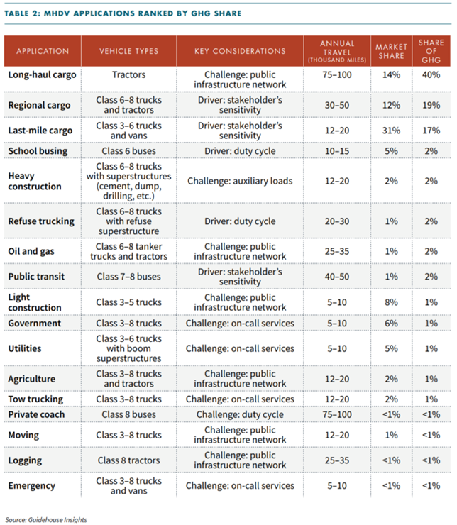
    - Source Guidehouse Insights: <https://guidehouseinsights.com/>
* EPA Motor Vehicle Emission Simulator (MOVES)
  + [https://www.epa.gov/moves/latest-version-motor-vehicle-emission-simulator-moves](https://www.epa.gov/moves/latest-version-motor-vehicleemission-simulator-moves)
* Fuels Institute. April 2022. The Easiest and Hardest Commercial Vehicles to Decarbonize.
  + Top 5 markets:
    - 5. Regional cargo
    - 4. Last-mile cargo
    - 3. Refuse trucking
    - 2. Public transit
    - 1. School busing
  + Bottom 5 markets:
    - 5. Tow trucking
    - 4. Logging trucks
    - 3. Heavy construction
    - 2. Oil and gas trucking
    - 1. Long-haul cargo
* International Council on Clean Transportation (ICCT). May 2023. Near-term infrastructure deployment to support zero-emission medium- and heavy-duty vehicles in the US. White Paper. <https://theicct.org/wp-content/uploads/2023/05/infrastructure-deployment-mhdv-may23.pdf>
* MJB&A. July 2021. Medium- & Heavy-Duty Vehicle: Market Structure, Environmental Impact, and EV Readiness. White Paper. <https://www.edf.org/sites/default/files/documents/EDFMHDVEVFeasibilityReport22jul21.pdf>
  + Market segments:
    - A list of vehicles with text

      Description automatically generated
  + For each market segment the number of vehicles in the segment was estimated using registration data collected from all 50 states by IHS Markit [1]. EPA’s MOtor Vehicle Emissions Simulator (MOVES3) model [2] was used to estimate the environmental impact of each market segment – from both a climate and air quality perspective.
    - The number of M/HD vehicles in each market segment was estimated using vehicle registration data collected by IHS Markit [1]. For each registered vehicle IHS uses data encoded in the vehicle identification number (VIN) to identify vehicle attributes. The VIN-defined attributes used for this analysis include Gross Vehicle Weight Class, Fuel Type, Vehicle Type, and Manufacturer. In addition, IHS assigns a Registration Vocation based on the entity that registered the vehicle.27
    - Certain VIN-defined vehicle types map directly to the market segments used here – for example PICKUP, VAN CARGO, BUS SCHOOL, and TRACTOR TRUCK – because they are definitively descriptive of the final vehicle configuration. Others are more ambiguous and provide little information about the actual vehicle configuration and use – examples include CAB CHASSIS, STRAIGHT TRUCK, and INCOMPETE (STRIP CHASSIS).
    - For this project, assignment of vehicles to each market segment is therefore based on a combination of VIN-defined Vehicle Type and, if necessary, IHS-defined Registration Vocation and weight class.
  + A screenshot of a vehicle weight class

    Description automatically generated
  + A screenshot of a chart

    Description automatically generated
  + EPA estimates that in 2020 the M/HDV fleet consumed 55.3 billion gallons of fuel and emitted 561 million metric tons (mill MT) of greenhouse gases (GHG), 1.5 million MT of nitrogen oxides (NOx) and 38,000 MT of particulate matter (PM)11 [2].
  + **see example fleet electrification commitments for list of companies

## Methods ?

* Set up classification for MHDV
* Identify larger fleets, companies, etc.
* Estimate fleet size
  + IHS Markit data / DMV (?) ask James
    - James (access); Ben (ins-and-outs)
    - From MJB&A. July 2021. Medium- & Heavy-Duty Vehicle: Market Structure, Environmental Impact, and EV Readiness. White Paper
      * The number of M/HD vehicles in each market segment was estimated using vehicle registration data collected by IHS Markit [1]. For each registered vehicle IHS uses data encoded in the vehicle identification number (VIN) to identify vehicle attributes. The VIN-defined attributes used for this analysis include Gross Vehicle Weight Class, Fuel Type, Vehicle Type, and Manufacturer. In addition, IHS assigns a Registration Vocation based on the entity that registered the vehicle.27
      * Certain VIN-defined vehicle types map directly to the market segments used here – for example PICKUP, VAN CARGO, BUS SCHOOL, and TRACTOR TRUCK – because they are definitively descriptive of the final vehicle configuration. Others are more ambiguous and provide little information about the actual vehicle configuration and use – examples include CAB CHASSIS, STRAIGHT TRUCK, and INCOMPETE (STRIP CHASSIS).
      * For this project, assignment of vehicles to each market segment is therefore based on a combination of VIN-defined Vehicle Type and, if necessary, IHS-defined Registration Vocation and weight class.
* Convert fleet size to GHG emissions
  + Potentially for environmental impact as well – EPA MOVES3
  + Grab MHDV-related emissions from:
    - <https://fueleconomy.gov/>
    - <https://www.epa.gov/greenvehicles/learn-about-fuel-economy-label>

## 4/30/2024

* investigate EMFAC vs MOVES
* find DMV data
  + assuming registration == domicile for right now
* differentiating MHDVs for fleets in the area that is SPECIFIC to the logistics industry
  + VIUS data is for all of CA; ratio of
* review EMFAC and extrapolate out how much emissions per vehicle (compare to subregion values)
  + normalize by light-duty vehicles
  + grabbing all EMFAC data, normalizing across the state
  + identifying if there is a unusually large peak in the region that we can attribute to warehousing

5/8/2024

* initial investigation into fleet size (normalized by total fleet size and per capita) doesn’t show a trend that highlights San Bernardino or Riverside
* looking further into EMFAC and running model specifically for GHG and environmental data
  + pulling data aggregated to each county is taking a while, still exploring
  + need to normalize by LDV when data is available
* James - look into the types of vehicles specifically associated with warehousing (with the categories of MHDVs provided by EMFAC - e.g., we can ignore dump trucks and should focus on interstate delivery, etc.)